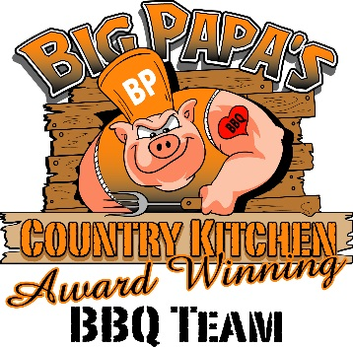BIG PAPA’S COUNTRY KITCHEN

MENU
Pulled Pork Sandwich $7.00
Pulled Pork cup (no bun) $7.00
Pulled Pork Dinner $11.00
BBQ Sundae $9.00
(16 oz cup, Beans, Slaw, Pork)
Chicken Sandwich $7.00
Chicken Dinner $11.00
Brisket Sandwich $9.00
Brisket Dinner $13.00
Rib Dinner $13.00
Hot Dogs $3.00
Hamburgers $4.00
Cheeseburgers $5.00
French Fries $4.00
Cheese Fries $5.00

Drinks:
Coke, Diet coke, Sprite $1.00

Sides:
Baked Beans
Cole Slaw
French Fries

